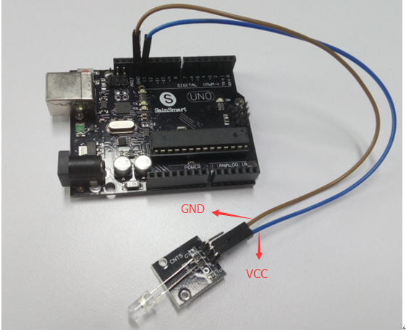

/\*

Blink

Turns on an LED on for two second, then off for two second, repeatedly.

This example code is in the public domain.

\*/

void setup() {

// initialize the digital pin as an output.

// Pin 13 has an LED connected on most Arduino boards:

pinMode(13, OUTPUT);

}

void loop() {

digitalWrite(13, HIGH); // set the LED on

delay(2000); // wait for a second

digitalWrite(13, LOW); // set the LED off

delay(2000); // wait for a second

}